**Query 2 sem index:**

SELECT COUNT (d.idt_employee) as qty_Director, AVG(d.salary) as mean_salary_Director,

COUNT (m.idt_employee) as qty_Manager, AVG(m.salary) as mean_salary_Manager,

COUNT (es.idt_employee) as qty_Especialist, AVG(es.salary) as mean_salary_Especialist,

COUNT (a.idt_employee) as qty_Analyst, AVG(a.salary) as mean_salary_Analyst

FROM employee as e

LEFT JOIN director as d ON d.idt_employee = e.idt_employee

LEFT JOIN manager as m ON m.idt_employee = e.idt_employee

LEFT JOIN especialist as es ON es.idt_employee = e.idt_employee

LEFT JOIN analyst as a ON a.idt_employee = e.idt_employee

Relatório do plano de consulta a partir do comando explain do Postgress:

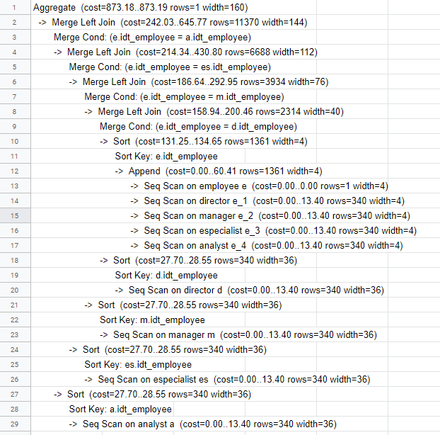

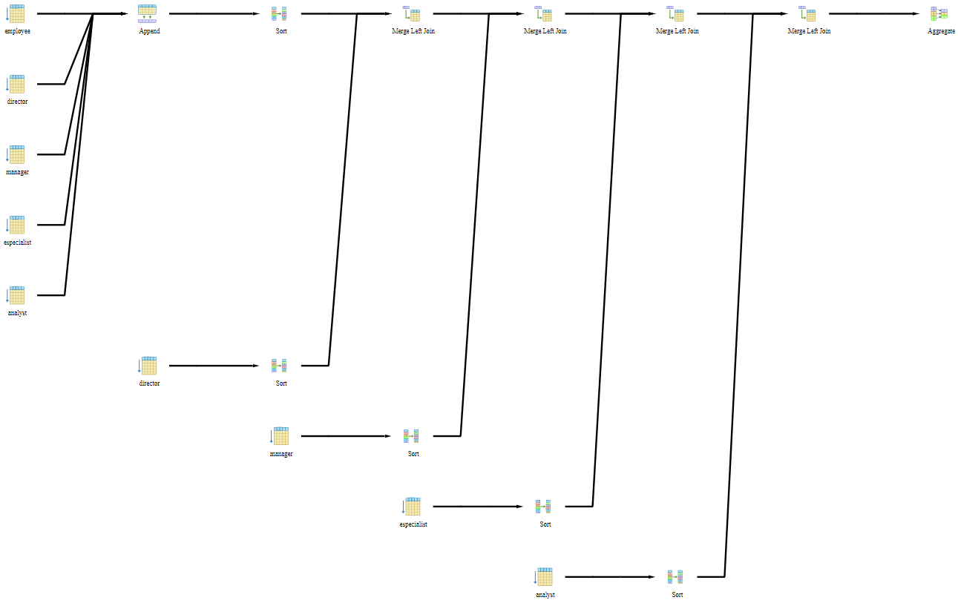

**query 2 com index:**

CREATE INDEX indicesegundaQuery

ON director (idt_employee);

CREATE INDEX indicesegundaQueryManager

ON manager (idt_employee);

CREATE INDEX indicesegundaQueryEspecialist

ON especialist (idt_employee);

CREATE INDEX indicesegundaQueryAnalyst

ON analyst (idt_employee);

Relatório do plano de consulta a partir do comando explain do Postgress:

